The Year of the Word
The Catholic Bishops’ Conference of England and Wales have designated 2020 as 'The God Who Speaks': A Year of the Word to celebrate the 10th anniversary of Verbum Domini - Pope Benedict XVI’s Apostolic Exhortation on ‘The Word of the Lord’, and the 1600th anniversary of death of St Jerome, who translated the Bible into Latin.
Therefore, 2020 will be a year of celebrating, living and sharing God's word, through a range of events, activities and resources, available across England and Wales.
At St John Fisher, we started our celebration of The Year of the Word with the delivery of special Bibles to Class R from the Diocesan Education Service.
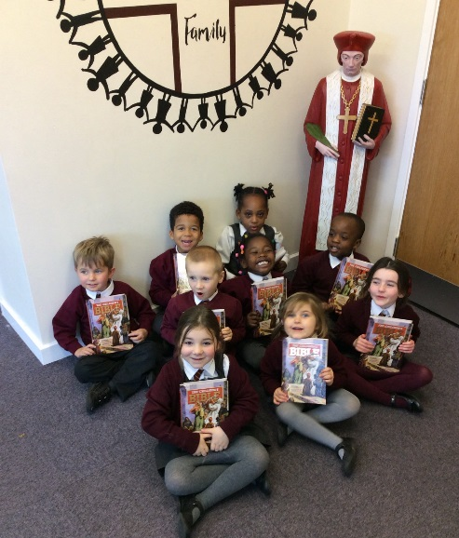

We took part in the National Youth Fun Day and we were delighted to welcome The Briars Team for their ‘Live and on location’ part of the day. We spent the day exploring scripture and celebrating our understanding of being ‘Significant’.
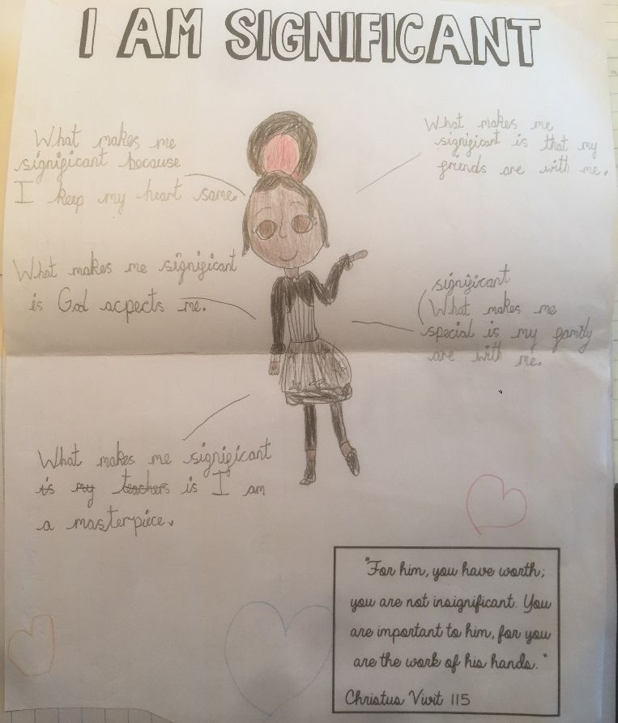
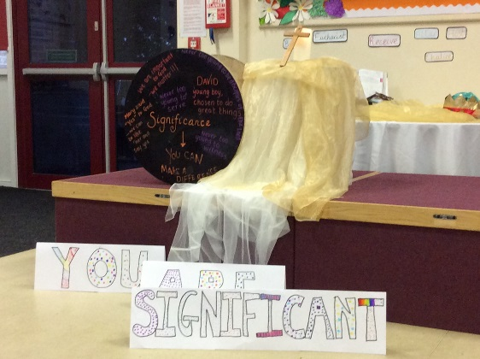

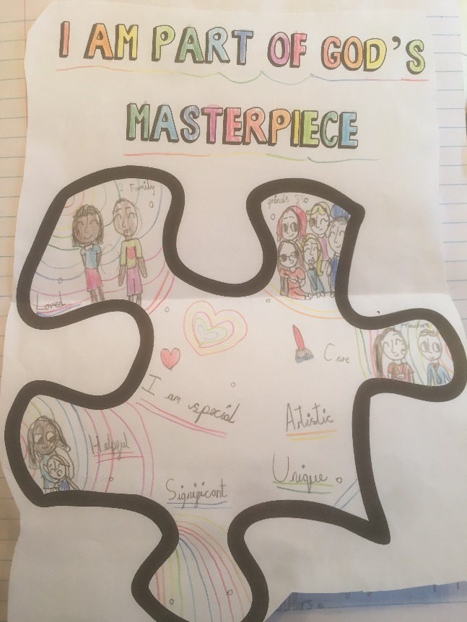
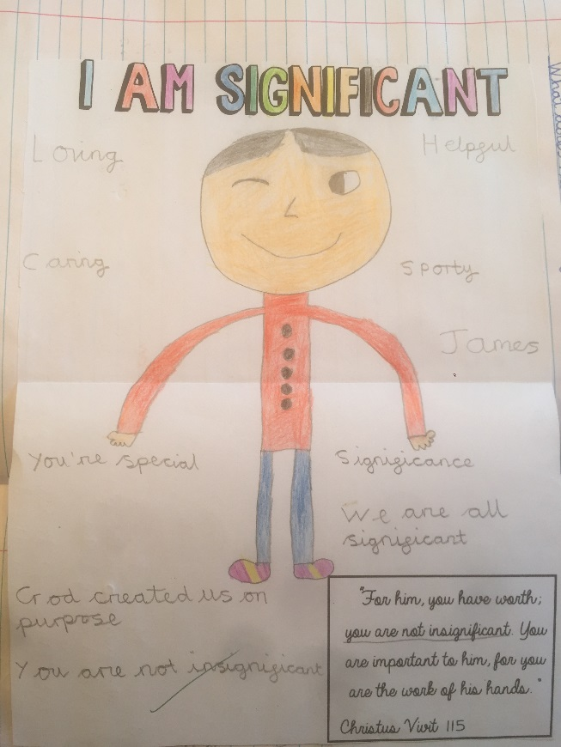
The chaplaincy team has taken the lead on our new and exciting Lunchtime Prayer Sessions. Children from KS1 and KS2 will get the opportunity to hear and learn stories from the Bible in fun and exciting ways. They will also explore the meaning of prayer and share their learning with others.

