Bishop Patrick’s Three Spiritual Themes
In 2018, Bishop Patrick asked us to promote his three spiritual themes of:
Encounter (to call), Discipleship (to build) and Missionary Discipleship (to send). Throughout the year, we focus on one of these spiritual themes in everything we do.
ENCOUNTER
‘Because when we truly encounter the Lord and his love for each of us, and hear afresh each day his Gospel invitation to change our lives and follow him as his disciples, we will find that we want to share with others the difference that knowing and serving Christ makes to our lives.’ Pastoral letter of Rt Rev. Patrick McKinney, our Bishop, Dec 2018
The words of Bishop Patrick inspire us at St John Fisher to Encounter the Lord and become his disciples. Each day, we work together to spread his message of love and friendship in our school, parish and wider community.
We Encounter the Lord in many ways at St John Fisher:

Encounter through personal prayer
Throughout our school, in classrooms, the hall, intervention rooms and foyer, are opportunities for children and staff to encounter the Lord through prayer and reflection.
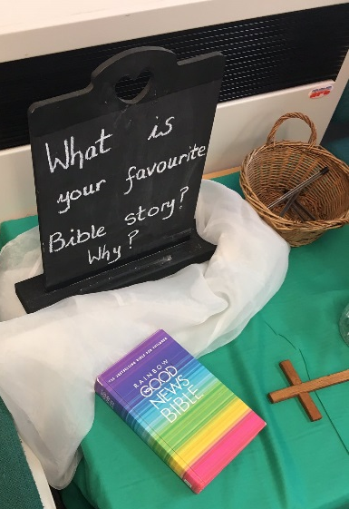
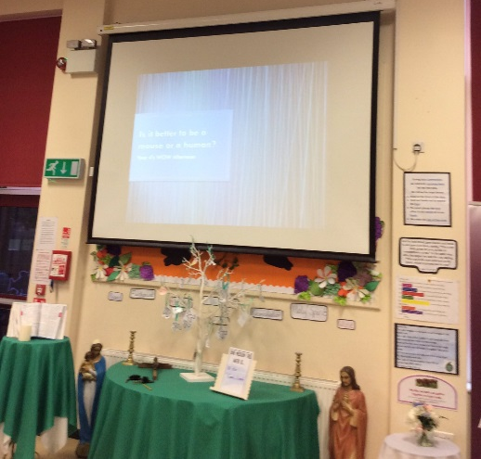
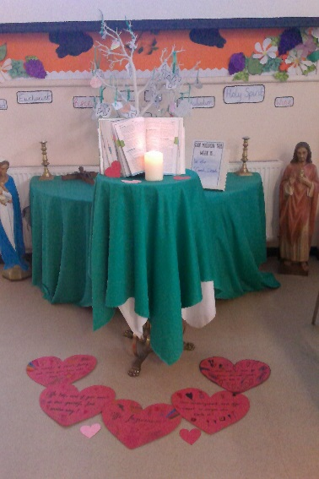

Encounter together
We spend time together encountering the Lord as a class and as a whole school community. These are led by either the Chaplaincy team, our classmates or our teachers. Together we are guided and supported to develop our relationship with the Lord.

Encounter through our work
In every RE lesson, we are encouraged to encounter the Lord in our work. This could be at the start of a lesson with a question, during a lesson or at the end of a lesson through reflection and discussion. Each moment gives us the opportunity to develop our relationship with the Lord.
“It is in our dark times that we need God the most. We learnt in our Sources topic that the Bible can help us in times of darkness. It is our power source; it keeps our light shining bright.”

Encounter through charitable giving
Our encounters with the Lord teach us about the importance of showing love, justice and responding to the needs of others less fortunate than us around the world.
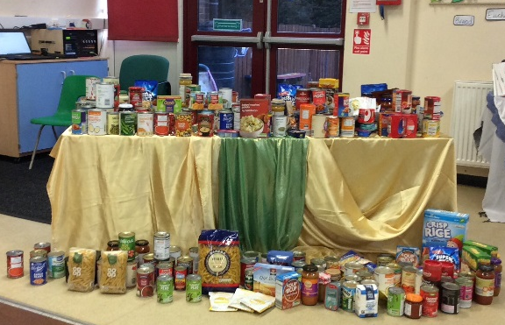

DISCIPLESHIP
“The disciple is someone who is trying each day to move from a ‘me-centred’ relationship with Christ, to one that seeks to hear and respond to what Christ may be asking of them.” Pastoral letter of Rt Rev. Patrick McKinney, our Bishop, March 2019
Through our personal encounters with Christ, we hear and respond to his invitation to be his disciples through scripture and readings from the Gospel.

ACTS OF WORSHIP
To fully understand God’s mission for us all on Earth, we hear his word through scripture each week by taking part in a range of Acts of Worship.

Mass
Fr Mark, our parish priest, leads us in mass each term to celebrate with our family, friends and parishioners. These masses are planned, prepared and delivered by the children and staff of St John Fisher linked to a specific theme to encourage us to reflect on our mission as disciples of God.
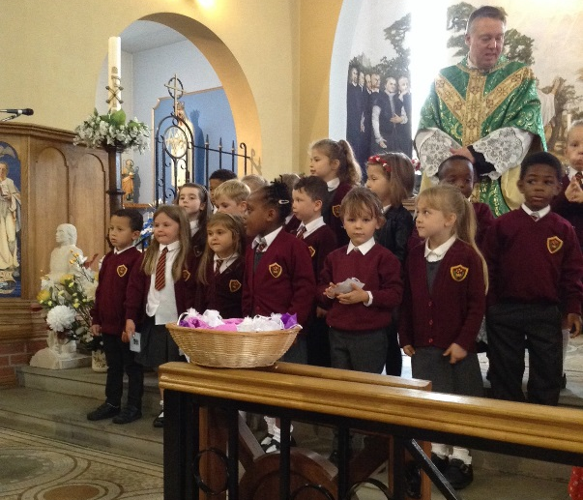
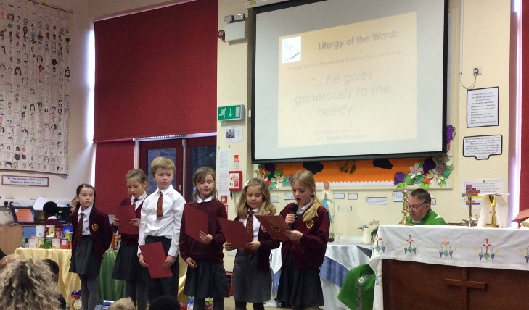
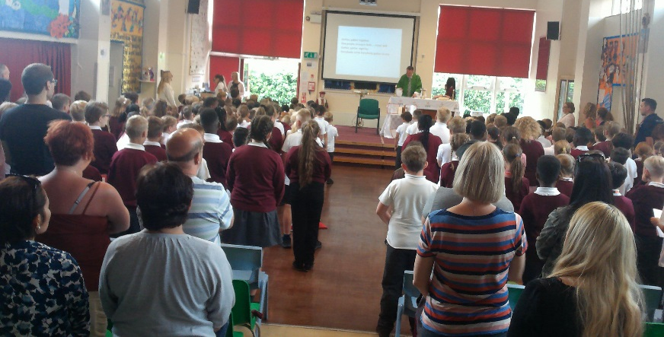
Whole

Whole School Gather and Pray
Every Monday, Mr Ackers or Mrs Brett lead us in a whole school Gather and Pray. During this Act of Worship, we hear the scripture from Sunday’s mass and reflect on how we can live this out in our own lives throughout the week as a disciple of Christ.
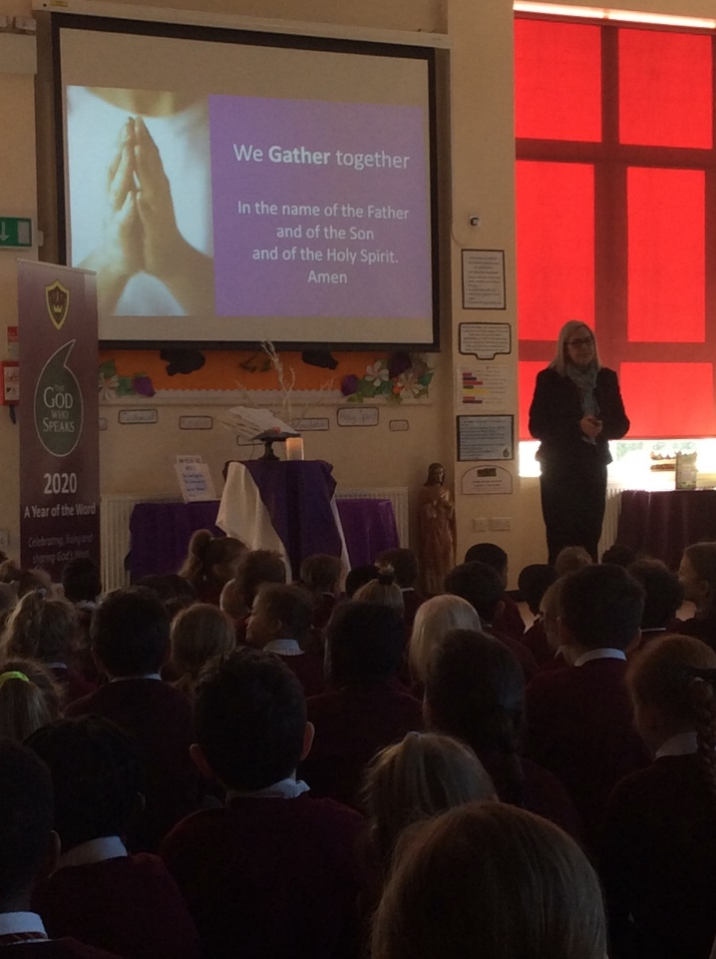

Class Liturgies
At the end of each RE topic, children plan, prepare and deliver a special liturgy which concludes their learning and encourages children to reflect on the importance of sharing scripture with others.
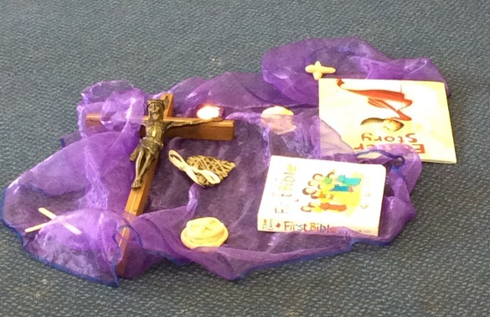
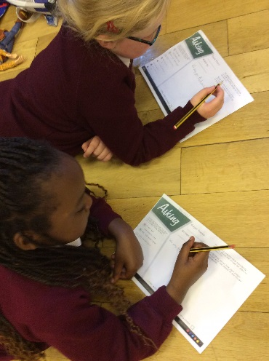
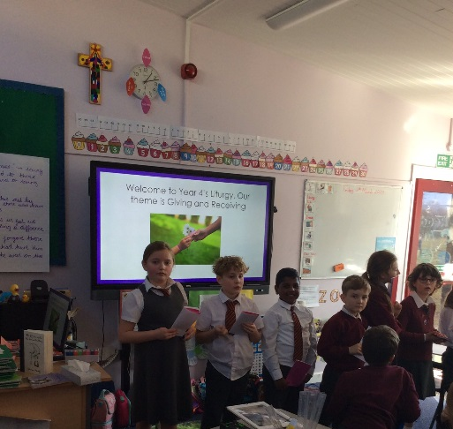

Key Stage Gather and Pray
Every Wednesday and Thursday, KS1 and KS2 gather together to hear and respond to scripture readings from the Bible. As part of our celebrations for ‘The God Who Speaks - The Year of the Word’, each class has been focusing on scripture readings from Matthew’s Gospel across both Key Stages. These liturgies are planned, prepared and delivered by the children from each class. After each liturgy, the children get the opportunity to reflect on the words and responses they heard by completing a personal impact and evaluation.

Whole School Gather and Sing
Every two weeks, we gather together as a whole school to Gather and Sing. Each playlist links to the current theme in the Liturgical calendar and encourages children to spread the God’s message through song.

MISSIONARY DISCIPLESHIP
At St John Fisher, we are proud of the hard work we undertake to support different charities both locally and globally. Pupils, staff and parents understand the importance of showing love and support to those in need.
The Chaplaincy Team meet regularly to discuss and plan a variety of fundraising events to support a variety of charities. Here are some of the activities we have undertaken which help us to encounter Christ through charitable work as missionary disciples.

Rainbows Hospice
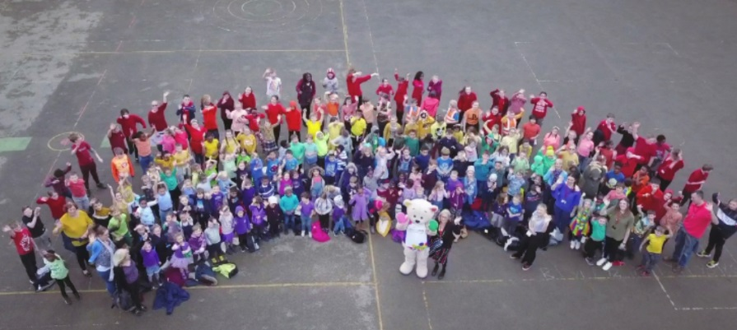
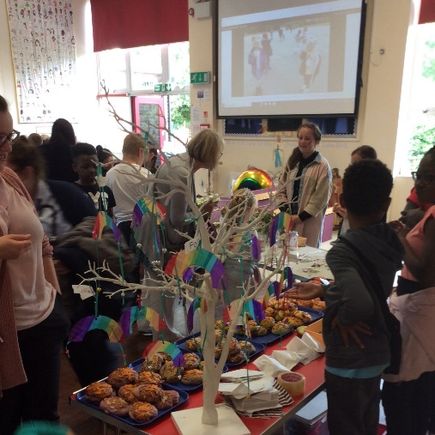

Project Arusha
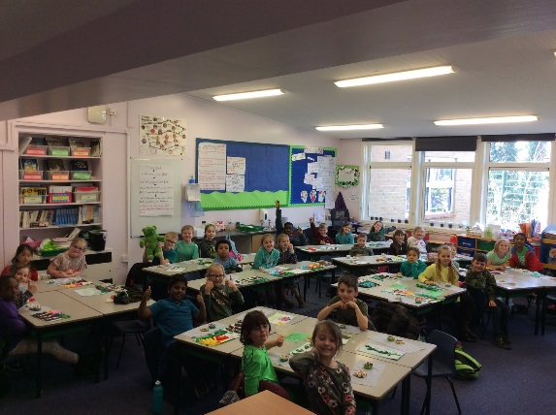

Macmillan Coffee Morning

Padley Centre and Doorsteps

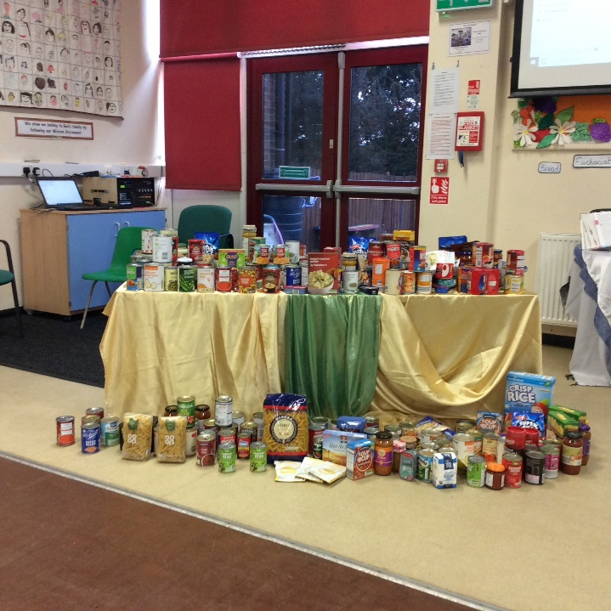
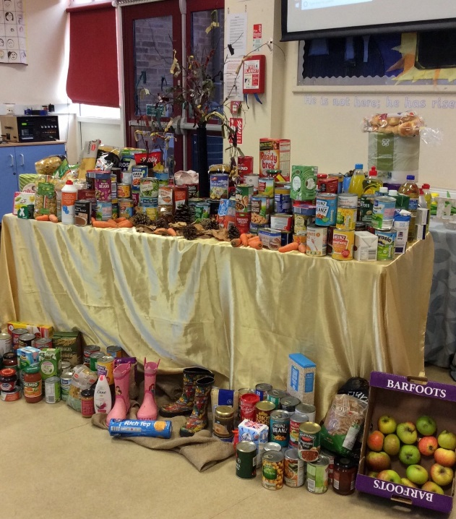

CAFOD

